Winter Mountaineering and Climbing Instructor Workbook

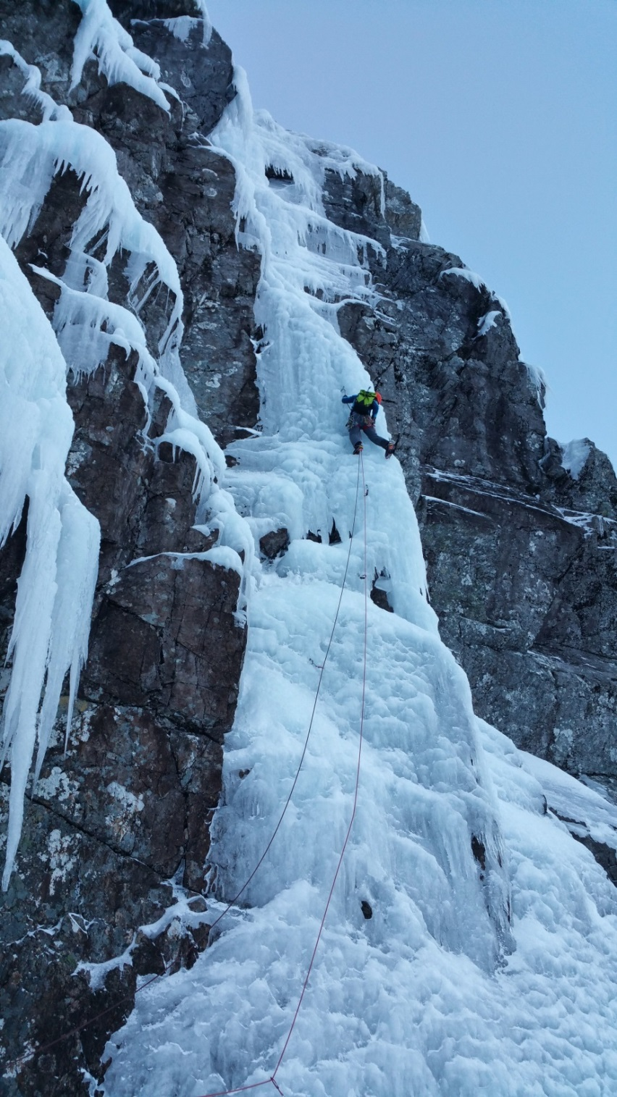

2023

Contents

Topic | Page Number
Introduction | 3
Training Course Programme | 4
Snow & Ice Craft  - Teaching Movement Skills | 6
Snow & Ice Craft  - Snow& Ice Anchors | 9
Avalanche | 13
Mountaineering  - Short roping & Pitching | 15
Winter Climbing | 17
Winter Climbing  - Parallel | 19
Winter Climbing  - Series | 21
Winter Climbing  - 1 Rope 2 Clients | 24
Winter Climbing  - Teaching Winter Climbing | 25
What is not included | 31
Bibliography | 32
Self-Appraisal | 34
Consolidation and Assessment | 39
Appendices | 42

Introduction

Welcome to your WMCI Training Course at Glenmore Lodge.

We hope that you will find your course of considerable technical and personal interest. These notes are designed to complement the training and coaching provided by your trainers. They are not designed to be exhaustive, but instead aim to provide a template to what has been covered during the course. We recommend that you add notes at the end of each day to this workbook. Also contained are some pointers to further reading and resources which will help you develop as an WMCI and prepare for an assessment.

Winter mountaineering is, by its very nature, a challenging activity. Weather, conditions and personal abilities all combine to produce an environment that is constantly changing and to an extent, unpredictable. For any mountaineering instructor to work effectively and safely in this type of environment their whole approach needs to focus on being flexible and adaptable such that they can manage the unpredictable, unusual and unexpected situations that can and will arise. Fixed routines and an “I always do it this way approach” will sooner or later encounter a situation where they are no longer applicable.

To that end a major part of this course focuses on not just learning new techniques but also developing your awareness of their pros and cons such that you can apply the most appropriate technique for a given situation - in essence developing sound judgment skills.

During the week you will work with a number of instructors. Each instructor often has their own way of doing particular tasks, there is very rarely just one way of doing something. Please feel free to question everything and anything. At this level many questions no longer have a clear-cut answer – oh and if any of the instructors on your course say it “depends” they should give an answer as to why it “depends”. Remember when working as a Mountaineering Instructor you should always be able to justify your actions and decisions.

We hope you enjoy your course.

Glenmore Lodge

How to use this document

This document should be seen as a working document and will hopefully cover the basic flow of your training. This is done with the concept that at the end of each day you add notes, diagrams, pictures etc. to re-enforce your learning. Some areas have deliberately been left blank for you to add notes.

Please note if you are going to print this document then the articles in the appendices at the back are slow to print!!

Training Course Programme

The programme is provisional, conditions and trainee needs may necessitate some changes. Days will be switched if weather or hill conditions dictate.

DAY | DAYTIME | EARLY EVENING | LATE EVENING
1 | Introduction  Course Programme  DLog  SNOWCRAFT  Local  Avalanche  BAA plan for day and journey observations: Surface stability observations only. Identifying scale of spatial variation.  Snowcraft Skills  Difference between WML and WMCI  Winter Snow Belays  Bucket seat; buried axe; climbing tools; bollard; stomper  Rope work & belaying progressions from WML to climbing  Review of the day | SHORT ROPING PREP  Short roping  Diff between MCI & WMCI  Pros and Cons  Setting up of the rope  Approach aprons or scrambling/mixed  Rope systems  Distance between student & instructor  Locked off coils v use of knot/hitch | BAA Avalanche Lecture
2 | MOUNTAINEERING  Local  Avalanche  BAA plan for day and journey observations:  Stability assessment theory, Strength, Energy, Structure.  Short Roping  Application of techniques covered on evening session  Short roping at 1:1, then 1:2. Up, down & across slopes  Moving over small steps  Holding slips; Lowers  Emphasis on maintaining a good ‘pace’  Changeover from short roping to short pitching  Short Pitching  Pitching up & then descending straight forward steep ground using single rope with two students  Emphasis on efficiency and safety  Using variety of appropriate anchor types  Stance management and organisation  Transition at base of climb  Review of the day | WMCI Avalanche Lecture

3 | CLIMBING - IN SERIES  Local  Avalanche  BAA plan. Journey observations, human factors management tools.  Climbing  Client care and approaching the route options  Transitioning from approach to climbing  In series pros and cons. Teaching progressions  Stance organisation. Location, preparation.  Rope management.  Rope system changeovers and options e.g. Series to Parallel  Abseiling  Review of the day | Teaching Winter Climbing Tutorial  - Profiling a winter climber: TTPP topics  - Meeting the needs of the clients  - Managing Leading | Self-Programmed  - Create example lesson plans for Friday
4 | CLIMBING – IN PARALLEL  Lochaber area or North West  Avalanche  BAA plan. Journey observations, human factors management tools.  Approach: as appropriate? When do we do what?  Crampon technique - flat; front point; hybrid  Use of axe from walking to simple climbing  Changeover from short roping to climbing at 1st stance.  Parallel pros and cons.  Personal movement on ice.  Stance organisation. Location, preparation.  Ice screw placements and belays.  Rope management and belay options. Teaching Progressions.  Rope system changeovers and options e.g. Parallel to one rope.  Descent  Emergency descents including multi pitch abseils  Bollards and Abolokovs  Lowers and other options  Review of the day | Self-Programmed  Complete self-appraisal forms
5 | TEACHING WINTER CLIMBING  Local  Teaching climbing skills (1:3)  Teaching options: -  Teaching progressions and rope system options.  Practice for teaching lead climbing in winter conditions.  Poor conditions options.  ‘Between Training and Assessment’  Individual debriefs

Snow & Ice Craft

Movement Skills
You should be able to:
- Demonstrate all the boot, crampon and axe skills perfectly in various conditions.
- Pick suitable locations to teach these skills in terms of appropriateness, maximum learning and safety.
- Understand the history and construction of the equipment.
- Have an awareness and understanding of different coaching models you can use for coaching these skills and all other aspects of winter mountaineering

Top Tips:
- Have a number of games to play to help deliver these skills
- Explore the “why", don’t just do
- Think about having a selection of small resources that can help teach
- Make sure you teach these skills in appropriate locations

Terrain Selection:

When delivering skills sessions, the terrain has to be appropriate to the skill taught. Whilst safety must be taken into account if the terrain is too easy or benign then learning will be minimal equally if the terrain is too difficult learning will be minimal.

When assessing appropriateness of terrain think of the following key factors:
- Difficulty
- The what ifs….run outs etc.
- Exposure
- Client experience
- Client confidence
- Weather conditions
- Aims and goals of session and client

Booteering:

You should understand when and where these skills are appropriate and competent in teaching kicking steps:
- front on
- slice/edging
- heel plunging

The links below are to videos on the Glenmore Lodge YouTube Channel

Choosing a winter boot - https://www.youtube.com/watch?v=tpKR8CtU8-g
Kicking steps - https://www.youtube.com/watch?v=qa0MpRlcSFM&index=2&list=PLrqtph4KNo5eR4rEAD698DJPL2kXoBGa0

Cramponeering:

You should understand when and where these skills are appropriate and competent in teaching all forms of cramponing:
- flat footing
- hybrid
- front pointing

The links below are to videos on the Glenmore Lodge YouTube Channel
Choosing crampons - https://www.youtube.com/watch?v=gPfMvzuPoXI&index=9&list=PLrqtph4KNo5eR4rEAD698DJPL2kXoBGa0
Using crampons - https://www.youtube.com/watch?v=NQ_WsqrP6us&list=PLrqtph4KNo5eR4rEAD698DJPL2kXoBGa0&index=5

Step Cutting:

You should understand when and where these skills are appropriate and competent in teaching all forms of step cutting:
- slash step
- side step
- slab step
- bucket step
- pigeonhole step

The links below are to videos on the Glenmore Lodge YouTube Channel

Choosing and Ice Axe - https://www.youtube.com/watch?v=B9RLIU-rJjI&index=10&list=PLrqtph4KNo5eR4rEAD698DJPL2kXoBGa0
Cutting Steps - https://www.youtube.com/watch?v=UUZ4u1Wtijw&index=3&list=PLrqtph4KNo5eR4rEAD698DJPL2kXoBGa0

Ice Axe Arrest:

You should be able to demonstrate all forms of ice axe arrest perfectly as well as break down the different types of arrest into stages to help with teaching. Remember where this session should fit in with teaching movement skills, if the above has been done well clients are unlikely to need this technique. Would it be better to spend time on the movement skills or ice axe arrests?

You should be able to demo and teach:
- self-belay
- on front feet first
- on back feet first
- on front head first
- on back head first
- log roll/tumble
- no axe

The links below are to videos on the Glenmore Lodge YouTube Channel

Self-Belay - https://www.youtube.com/watch?v=U8a8qhXoi0s&index=6&list=PLrqtph4KNo5eR4rEAD698DJPL2kXoBGa0
Ice Axe Arrest - https://www.youtube.com/watch?v=94QFImjdEAo&list=PLrqtph4KNo5eR4rEAD698DJPL2kXoBGa0&index=7

Coaching Models

As a WMCI you should have developed your coaching and teaching skills from your MCI Training and assessment. One way to access this is to engage with the Mountain Training coaching awards (Foundation and Development coach) or you may have experience of coaching from other disciplines that just needs a bit of thought to apply to a winter context.

The below is in no way an exhaustive list more a few ideas and pointers to get you thinking about your coaching and for you to go away and research the context of the below.

How your clients learn:

TARP: A model that looks at different learning styles, T=Theorist, A=Activist, R=Reflector and P=Pragmatist

How you structure you coaching:

IDEAS: A simplistic model for coaching structure I=Introduce, D=Demonstrate, E=Explain, A=Activity and S-Summary

WASP: Another simplistic model for coaching W=Watch, A=Analyse, S=Set Goals and P=Practice

How you give feedback:

PAT: A very simple process for giving feedback after a client does an activity P=Pause, A=Ask and T=Tel.

Remember that the above are just ideas and you should develop your knowledge around these ideas so that you understand these concepts and why they are used.

Snow & Ice Anchors
You should be able to:
- Build technically perfect snow anchors
- Understand how their structure and the snowpack combine to create strength
- Teach them in a logical and progressive way
- Select appropriate locations to teach these anchors
Top Tips:
- Practice making these anchors and testing them to destruction in different snow types
- Be sure you know why you are building them in the way you do
- Know what part of the anchor takes the load

As a WMCI you should know how to build these anchors, understand their strengths and weaknesses, select their use appropriately and differentiate between the different contexts of them (i.e. use in a Winter ML situation and use in a climbing situation).

The below anchors/types of belay method are ones you as an WMCI should know about even if you do not find yourself using them in your daily work.

See article in Appendices 1

Stomper:  Pros:  Cons: | 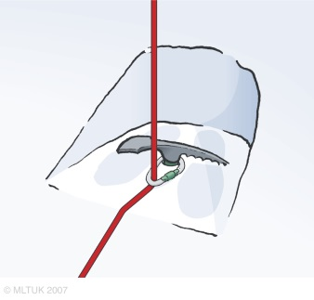 | 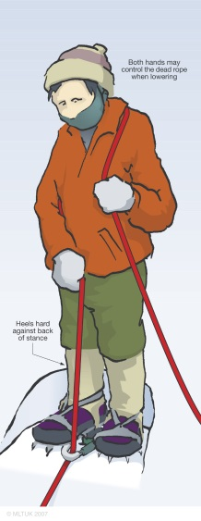

Modified Stomper:
Pros:

Cons:

Boot Axe:  Pros:  Cons: | 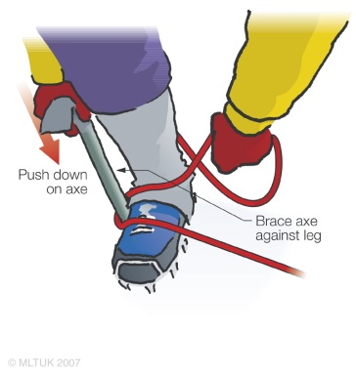

Bucket Seat:  Pros:  Cons: | 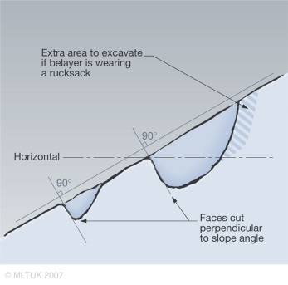 | 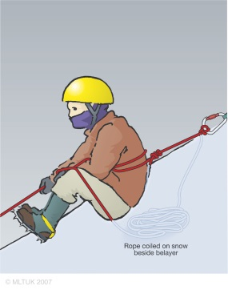
Digging a Bucket Seat – https://www.youtube.com/watch?v=84NTWlRVWd4&index=2&list=PLrqtph4KNo5dI-W2C4y7aJTZjdNWRQK71
Body Belaying – https://www.youtube.com/watch?v=1QaEnE5Gn2I&list=PLrqtph4KNo5dI-W2C4y7aJTZjdNWRQK71&index=3
Body Belaying in Climbing – https://www.youtube.com/watch?v=px0wunujoWA&list=PLrqtph4KNo5etvZe9LnHoX6HvcF9fQmFL&index=4

Horizontal Axe:  Pros:  Cons: | 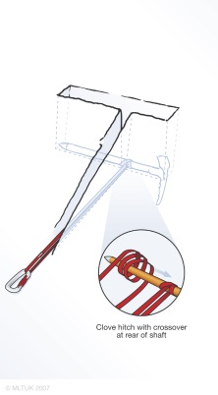 | 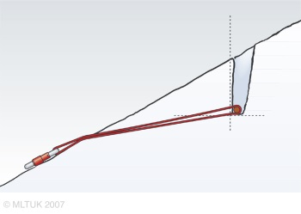
Buried Axe - https://www.youtube.com/watch?v=nVr-1ixsatY&list=PLrqtph4KNo5dI-W2C4y7aJTZjdNWRQK71&index=4

Snow bollard:  Pros:  Cons: | 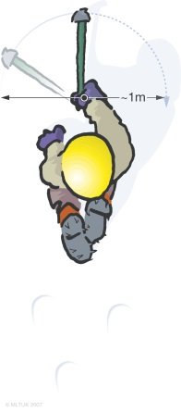 | 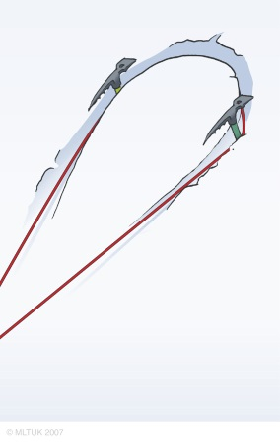
Building a Snow Bollard - https://www.youtube.com/watch?v=eI0UMjte7Ms&list=PLrqtph4KNo5dI-W2C4y7aJTZjdNWRQK71&index=5

T-Axe:  Pros:  Cons: | 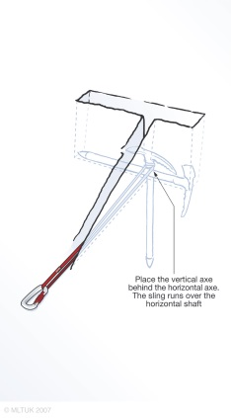

Dead Man:  Pros:  Cons: | 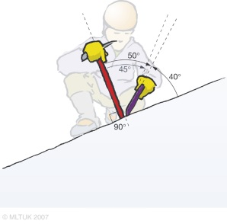 | 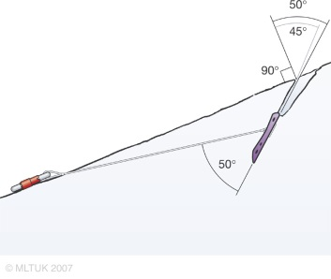

V-Thread:  Pros:  Cons: | 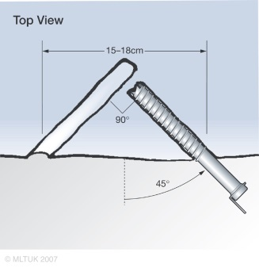 | 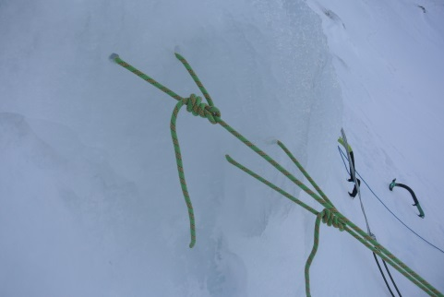
Making a V-Thread - https://www.youtube.com/watch?v=i2pea5VWDGU&list=PLrqtph4KNo5etvZe9LnHoX6HvcF9fQmFL&index=10
V-Thread for belaying – https://www.youtube.com/watch?v=ttfwNuUvT90&index=12&list=PLrqtph4KNo5etvZe9LnHoX6HvcF9fQmFL
V-Thread for abseiling - https://www.youtube.com/watch?v=30Asm4Mj_mQ&index=11&list=PLrqtph4KNo5etvZe9LnHoX6HvcF9fQmFL

Avalanche
You should be able to:
- Teach avalanche awareness using the Be Avalanche Aware process
- Continually assess a snowpack and relate it to your planning and key places
- Manage travel through complex terrain
- Explain the use and limitations of a wide variety of snowpack investigative tools
- Access snowpack and avalanche data
- Have knowledge of snowpack/avalanche theory
Top Tips:
- Become comfortable with using Be Avalanche Aware for you avalanche assessment
- Have some resources to reinforce BAA whilst on the hill

Be Avalanche Aware Process

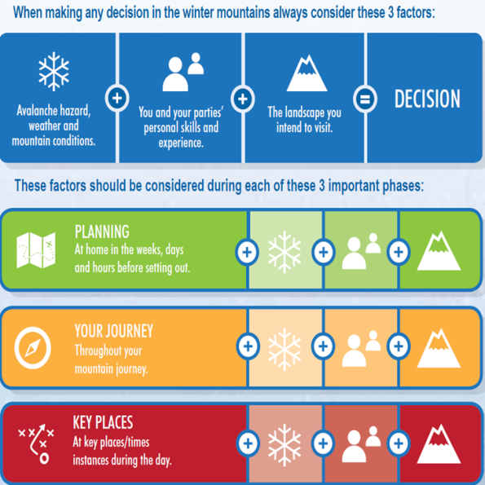

This is the process that has been developed by SAFOS and what we expect a WMCI to be conversant with.

Technical Knowledge

Whilst it may not be appropriate for a WMCI to spend much time teaching the technical theory side of snowpack it is important that a WMCI has a good knowledge of this. You should have a good understanding of:
- Types of Avalanche
- Initiation and Propagation
- Snow pack metamorphism
- Spatial variation

Snow Stability Tests

It is vital that a WMCI has a solid an understanding of the use of as well as the pros and cons of stability tests. You should be able to demonstrate these and explain the concept of them, eg:
- Hand Sheer
- Compression Test
- Extended Column Test
- Propagation Saw Test
- Rutschblock Test

You should also have an understanding of energy within the snowpack and propensity to propagate.

Route Choice

At Winter ML level you would be expected to travel through simple terrain in terms of avalanche risk, however at WMCI level you should be able to travel through complex terrain in terms of avalanche risk. You should recognise the challenges of this and some of the strategies, techniques and tools that you might deploy to allow you to do this.

Further Knowledge

Snowpack science and avalanche assessment is continually developing and it is impossible on a WMCI Training to cover everything that might be of interest and use to an WMCI. We would recommend that you use other CPD Workshops to continue to develop your knowledge of this area.

Avalanche Awareness for Mountaineers and Climbers and Delivering Avalanche Education for Professionals are suitable courses run by Glenmore Lodge - https://www.youtube.com/watch?v=R8XM_JFWWTw&index=2&list=PLrqtph4KNo5e9A-9LtWqKxnsebi7mssok

Mountaineering
You should be able to:
- Decide what technique is appropriate for the current situation
- Efficiently move clients around mountaineering terrain
- Change between short-roping, pitching and soloing as appropriate
- Explain your decision-making process

Top Tips:
- Have a system for measuring distances between clients and yourself
- Practice converting between short roping and pitching
- Practice in different types of terrain and different snow conditions
- Be aware of how your crampon points engage with the ground to help decide if you’re using an appropriate technique.

Short Roping

This should build on your skills as an MCI. Remember that everyone will short rope in slightly different ways as there are many variables it will always be a balance between:

Terrain – Number and size of Clients – Your Ability

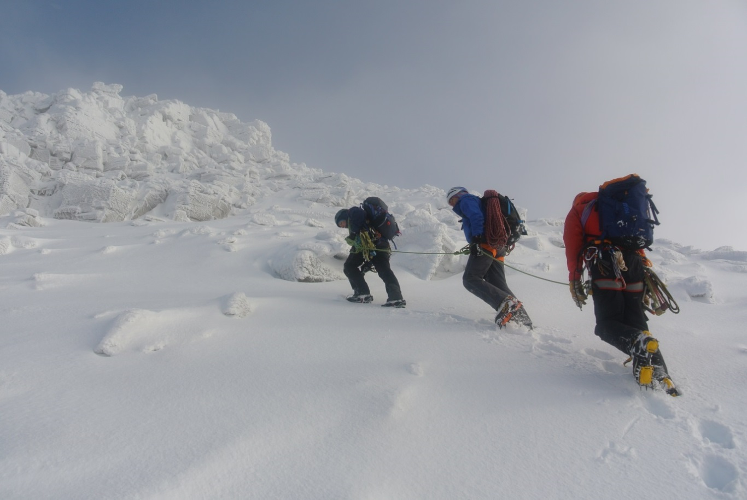

Some of the areas you should think about and be able to justify your actions are:
- How you tie off your coils
- The distance you have your clients apart
- How both clients are attached
- Types of hand coils and how many
- Use of the arm, bent, straight
- How you change direction in zig-zags
- Changing from short roping to dropping coils and running out a pitch
- Traversing

Shortening the rope to the client:
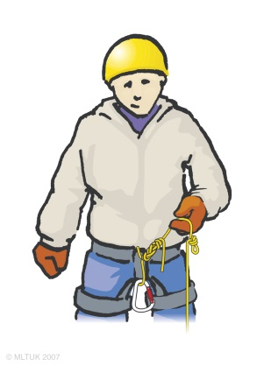 | 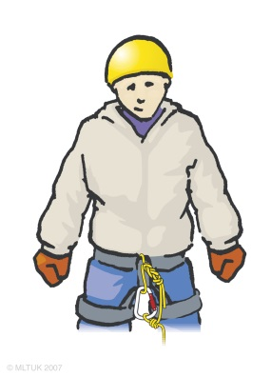 | 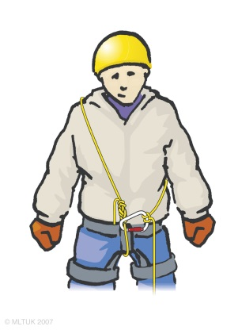

Short Pitching/Ledging

As a technique this is no different to summer just often with a different medium under your feet! Like summer there is a spectrum of security that needs to be balanced with flow and efficiency. The spectrum of security is:

Solo – Short Roping – Ledging – Pitching

It is up to you to be able to decide the most effective process for any given situation.

See article in appendices 2, 10 and 11
Winter Climbing

Introduction

Instruction and coaching students on multi pitch climbs presents the instructor with a variety of considerations, and possible problems. There can be a tendency to adopt techniques and styles that reflect not the student’s needs, but what are convenient for the instructor to use. Increasingly instructors may also find themselves in the role of guiding students up a route, which again presents us with a different set of needs. To start with all the topics are appropriate for both summer and winter situations.

The techniques described here are not meant to be the definitive guide to all aspects of multi pitch climbing with students. What is hoped is that it will promote thought, discussion and a greater awareness of the variety of aspects that make working with students on multi pitch routes such a challenging and demanding experience.

AIM - Before adopting rope/belay systems, we should first decide on the main aim of our session.
- Teaching
- Coaching
- Guiding

Methods used should meet the following criteria:
- Be safe
- Reflect aims of session

If your main aim is to guide this does not mean you cannot teach at the same time it just has less of an emphasis within the day.

Stance Management

Stance management is the general term used to describe the organisation of clients/students on a stance, on multi-pitch routes. This organisation includes elements such as correct belay plate orientation, rigging of anchors; placement of clients/students on stance relative to a variety of factors e.g. hazards, belaying, direction of the next pitch, organisation of ropes, and appropriate client/student briefings.

It is perhaps the most difficult part of working on multi-pitch routes to do efficiently as solutions tend to involve not just using the most appropriate techniques but adapting the relevant skills to the type of stance you are using.

Many problems can be avoided if you work forward from first principles i.e. what are you trying to achieve with your people in that session or pitch as aims can change whilst on a route, perhaps because you have misjudged your clients/students’ abilities or are running out of time. Such an approach will tend to narrow down your options to a manageable range.

There are a variety of techniques that you can use whilst working with students/clients on routes, below are some of the main principles involved in stance management.

Like many skills required by the mountaineering instructor there is no substitute for practice and experience working with real students/clients on multi-pitch terrain. As a current MCI holder you should be familiar with the points below.

Aims
- Safety of students/clients
- Efficient changeover at belays
- Reflect the aims of the session

Basic Points
- Stance can accommodate clients/students
- If appropriate, be in visual contact with students on ‘hard’ pitches
- It is safe i.e. good anchors, no danger of falling rock/ice/leader on students/clients
- Is organised such that the leader can move off with the minimum of fuss and disruption
- Students are NOT left to deal with any tangles or twists

Making it efficient
- Leader and clients stacked in climbing order
- Students/clients clipped in without crossing ropes
- Engage students with jobs such as stacking ropes
- Outside of stance clear (e.g. no axes or human runners!)

See article in appendices 3 – Protecting winter belays

Parallel Ropework
You should be able to:
- Climb at grade III or above placing appropriate gear and keeping the ropes separated well in an efficient manner.
- Understand the constraints of using a direct belay
- Execute stance change overs with no tangles or twists
Top Tips:
- Have a system for your stance change overs.
- Be happy converting from series to parallel rope systems and vice versa whilst mid route.
- Climbing at grade IV or above, this will allow you to climb grade III happily.

Parallel Rope System:

This would be the normal system for guided climbing as it allows for both seconds to climb at once and so will be faster. However, it is still possible to instruct with this rope system. Movement techniques can still be coached, gear placed and removed and clients can still build their own belays if appropriate. Think of this system as guiding with a capital ‘G’ and instructing with a small ‘i’!
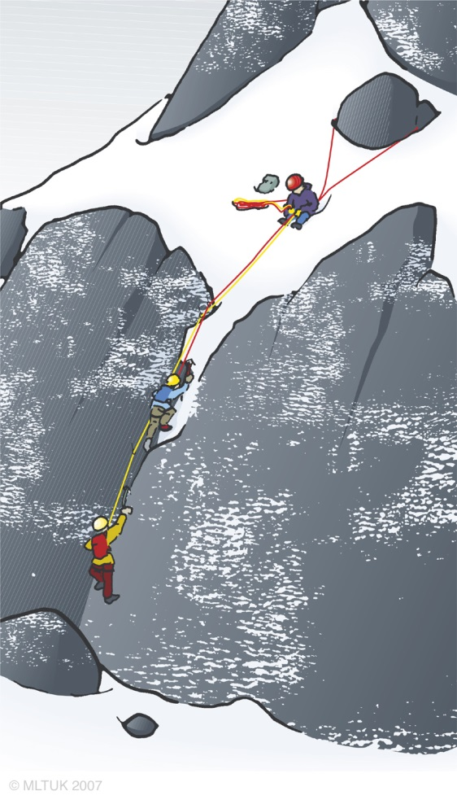

Pros:
- Flexible in that both can climb at the same time if desired or one at a time
- Allows second student to be tied off, if moving one at a time, thus protecting them should they inadvertently dismantle the belay
- Stronger student can help weaker by presence
- Fast as both students can climb at same time
Cons:
- Ropework and stance management is harder to avoid tangles
- Student can get caught up in other rope, if ropes not well separated
- Can be heavy work for the leader dragging two full ropes behind as well as harder work belaying two ropes at once.

Direct Belay System:

Whilst using parallel ropework for guiding, the normal belay system to use would be a power-point or single point anchor and direct belay using a guide plate. However, either for safety reasons or teaching purposes it is possible that you may decide to belay in a more traditional method and use the rope to equalise the anchors. This system will require more dexterity and management.

Pros:
- Less strain on belayer
- Leader not in the system
- Fast method of bringing up second(s)
- Two students can be brought up independently and simultaneously.
Cons:
- Not generally standard practice recreationally, therefore not a clear picture for teaching novice students.
- Requires ‘bomb proof’ anchors – not always available in winter
- Difficult/impossible to lower student(s) if loaded. Note: newer devices do make this process easier but you need to familiarise yourself with how they work.

Stance Management:

When speed and efficiency is the main reason for using this rope system the stance management is often controlled by the instructor. This will also allow you to execute the changeover system you use. Some things to think about are:
- Plan the next pitch
- Have your back to the direction of the next pitch
- Have your stance above the students
- High anchor points
- No dances on stances
- Already have ledges cut ready for students
- Think about a logical order to event

Series Ropework

You should be able to:
- Climb at grade III or above placing appropriate gear
- Demo good practice in terms of movement and gear placement even on easier routes
- Build appropriate belays
- Execute stance change overs with no tangles or twists
Top Tips:
- Look for appropriate teaching opportunities that are progressive and structured
- Be happy converting from series to parallel rope systems and vice versa whilst mid route
- Keep an eye on time and change to parallel if you need to save time
- Climbing at grade IV or above, this will allow you to climb grade III happily

Series Rope System:

This rope system provides the possibility of instructing climbing in a way that closely resembles what we do recreationally. Clients can equalise into anchors using the rope and build their own anchors, belay up a second and perform a multi-pitch changeover as if the second was leading through. The instructor climbs first but can alternate which clients come second and third each pitch. Think of this system as instructing with a capital ‘I’ and guiding with a small ‘g’!

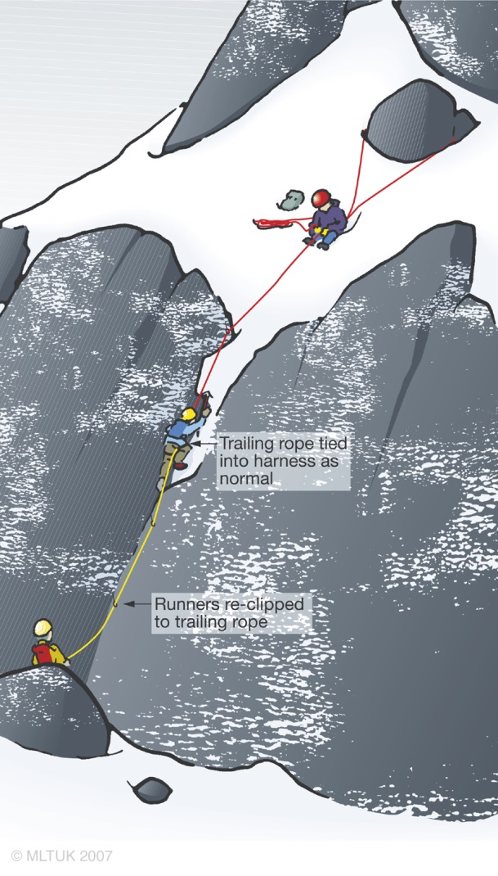

Pros:
- Allows the first student to adopt ‘lead’ climber behaviours e.g. clipping rope through runners
- Attention can be devoted to one student at a time
- Instructor can step out of the ‘point’ allowing the students to adopt a standard two-person rope (instructor can solo/self-line placing runners etc. as appropriate)
- Ropes easier for instructors to manage
- Student positioning can be changed to reflect swinging leads on a multi-pitch route
- Students can belay from above

Cons:
- Can be very slow (moving one at a time)
- Tiresome and lonely for last student
- Risk of last student falling full length of rope should they inadvertently be unclipped

Semi Indirect Belay System:

It is still possible to execute parallel ropework with this belay system, however this could be thought of as what we would do when we go climbing normally and is commonly deployed in series ropework. It can still involve slings to bring the anchor to a central point but then the climber ties in with the rope, or just the rope could be used to equalise the anchor. The belay plate is clipped into the rope loop on the harness. The position of the braking hand and plate orientation is crucial in this system.

Pros:
- Belay method is common practice recreationally
- Leader can devote attention to single client
- Can be easier to give a tight rope in extremis, or hoist
- Avoids full impact force on the belay in the event of a fall. (Use of rope, and dynamic belay increases dynamic element in system)

Cons:
- Difficult to bring two clients/students up at same time if moving at different speeds?
- Instructor is in the system necessitating a potentially complicated escape if required.

Stance Management:

If instruction is the focus more activity and ownership can be handed over to the clients. Some things to think about:
- Have the client copy the system you have used to tie in.
- Think of appropriate teaching opportunities (what is unique to the winter multi-pitch stance?).
- What order do you want the clients to move in, have them stand in that order.
- Think carefully about plate orientation.
- Have a clear process for teaching stance change overs.
- Double check all knots if untying and re-tying.
- Consider taking the less obvious belay while leaving the easier placements for the students to use in their belay.

Two Clients on One Rope

This could be seen as a progression from short pitching in mountaineering. It is often used to approach winter routes or to top out on very simple but serious finishes to routes.

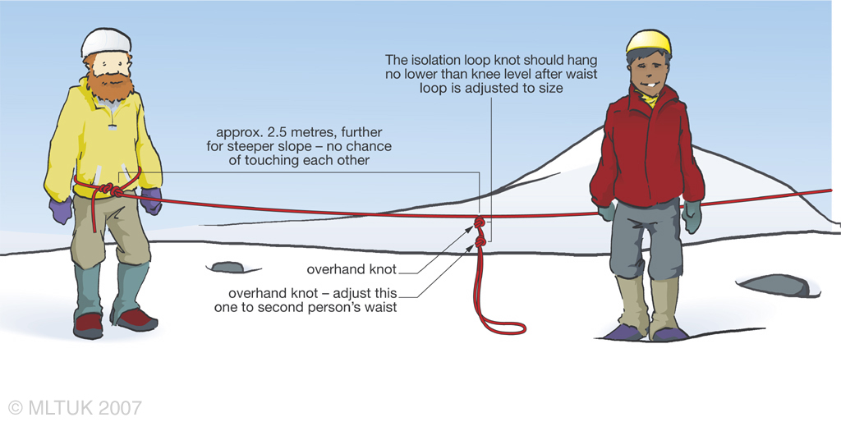

Pros:
- Simplified rope work.
- Fast to use – both students climb at the same time.

Cons:
- Only suitable on straightforward, easy ground.
- Students must be briefed to climb at compatible speeds.
- Can paint a confusing picture to clients as it is not a normal climbing process.

Belay System

Either of the belay systems already mentioned can be used in this system.

Stance Management

Some simple teaching can still take place here i.e. tying clove hitches, however do not confuse clients with teaching too much out of context. One area to look out for here is to pay attention to the client on the end of the rope so as not too much slack it created in the system.

Teaching Winter Climbing

You should be able to:
- Select appropriate climbs for the clients
- Deliver an appropriate day for the clients
- Create progression during the day/days
- Differentiate between the needs of different clients
- Assess the wants and needs of clients
- Teach appropriate skills in context of the situation
- Demonstrate good practice at all times
- Keep yourself and the client’s safe
Top Tips:
- Have a teaching progression in your head or written down
- Have a list of all the winter climbing teaching skills
- You are winterizing your MCI skills, make sure you are a practiced MCI in relation to teaching climbing
- Do not fixate on a climb but rather focus on the outcome goals for the day

Introduction

Teaching lead winter climbing to students is arguably one of the most demanding situations you may face as a WMCI. Not only are you working with novice climbers in an unpredictable and serious climbing environment, but you may well have to contend with long run outs between (possibly) poor runners. To complicate events you will have to ensure that your students possess a wide range of basic skills (technical & physical) before they start off on their first lead. All the techniques, skills and processes you use to teach leading in summer still have application in winter. Perhaps the main differences between teaching leading in winter as compared to summer, are the unpredictability of the winter environment and the increased seriousness this means.

Before clients lead a climb there is a progression to go through from novice to competent second to aspirant leader. This can be thought of as ‘Student Preparation’

Student Preparation

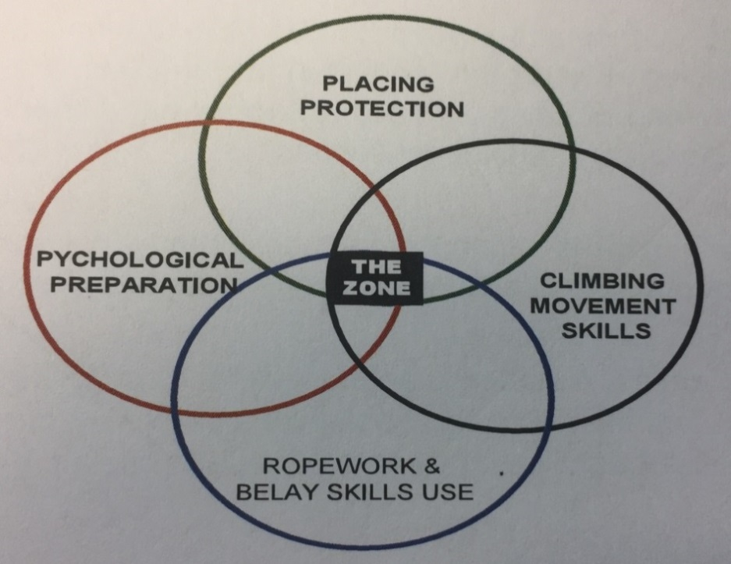

The diagram illustrates that for our students to operate in ‘The Zone’ (i.e. lead climb with a reasonable degree of independence) then we have to ensure that our students have a practical and working knowledge of the four key skills areas. If there were a lack in any of the key skill areas, then the onus would be on the Instructor to appropriately manage the situation (Some skill deficiencies are easier managed than others for example a lack of skill in placing protection may mean we pre-place gear, or closely supervise the student placing gear. A lack of proficiency in belay skills does pose the question, “Should that student be belaying their partner in a lead situation?”).

So what is involved in these ‘building blocks’?

Sample Progression Framework:

Ropework and Belaying | Placing Protection and Anchors | Movement Skills | Psychological Preparation
Put a Harness on | Remove simple gear (passive) | Climb simple snow slopes | Want to lead
Tie in | Remove complex gear (active) | Climb rocky steps | Understand and accept the risks
Belay a leader | Place simple gear (passive) | Climb ice bulges | Cope with mental strain
Hold fall (pull test) | Place complex gear (active) | Climb prolonged technical sections | Coping systems
Tie a clove hitch into an in-reach anchor | Understand and building bucket seat | Focus on crampons techniques
Belay a second | Understand and build horizontal axe | Focus on axe techniques
Tie a clove hitch in to an out of reach anchor | Understand and build snow bollard | Focus on body positioning
Use a rope to equalise an anchor | Extending and clipping gear
Abseil with a safety from instructor | Place gear in stressful positions
Abseil with own safety

A few Videos from the Glenmore Lodge YouTube page:

Placing Wires - https://www.youtube.com/watch?v=V6ZoOMFD9BA&list=PLrqtph4KNo5etvZe9LnHoX6HvcF9fQmFL&index=6
Placing Pegs - https://www.youtube.com/watch?v=BCsxtGvGors&list=PLrqtph4KNo5etvZe9LnHoX6HvcF9fQmFL&index=7
Placing Ice Screws - https://www.youtube.com/watch?v=6ps2VaiQ1T4&list=PLrqtph4KNo5etvZe9LnHoX6HvcF9fQmFL&index=8
Making an Ice Screw Belay - https://www.youtube.com/watch?v=eIIyetv__7A&list=PLrqtph4KNo5etvZe9LnHoX6HvcF9fQmFL&index=9

See articles in appendices 4, 5 and 9 on Ice Protection.

Checking it out:

It is vital that we check out if the clients can actually do the above skills. This should be done in a number of ways:
- Ask Questions – Make sure you ask the right questions that probe for information
- Seeing it – Back up the answers you gained in a practical way. This can be done in a top/bottom rope environment, specific technique session or more commonly by climbing a route in series.

Series Climbing

All the above building blocks (other than holding falls, although we can use the pull test) we can teach with a high level of student safety by having them climb in series. The advantage of this is that the middle student is imitating lead climber behaviours, albeit on a top rope. You can also have the students swap leads. This does require a high degree of slick rope organisation on your part to operate effectively and is also time consuming. However, it is ‘safe’ for the student ‘seconding’.

Teaching Lead Climbing

As instructors of winter climbing we face a real dilemma. We have students in a lead climbing situation. By definition lead climbing involves the (potential) risk of falling. If there is no risk of falling, it is not lead climbing. So to teach lead climbing we have to expose our students to the risk of falling - an activity in winter which can have very serious consequences.

The challenge for you as an WMCI involves a balancing act between teaching students lead climbing skills in a ‘real’ situation and the possible likelihood and consequences of your student falling. What we are aiming to do is balance the student’s actual level of climbing skill with the level of climbing adventure we set for them. Mismatch this challenge and we risk our students feeling bored. Get it right and they embark on a challenging and exhilarating learning experience.

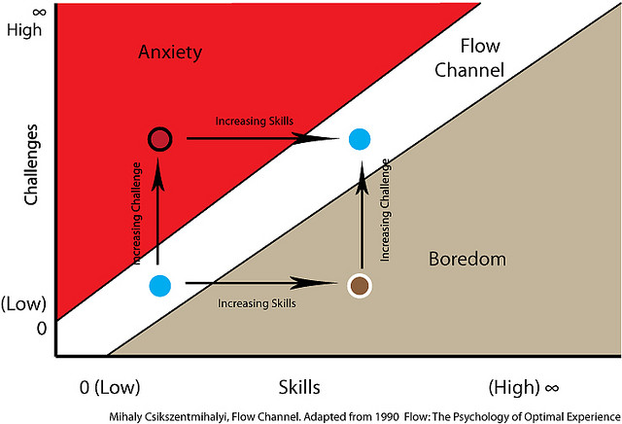

Ensuring Safety:
When teaching leading you have two options for looking after yourself these are soloing or self-lining.

Pros | Cons
Requires no specialist equipment | High Risk
Quick | Hard to sort a rescue (see note below)
You can (if safe) be by the student’s side coaching them
Soloing

It’s a good idea to carry a short length of rope and a light rack of protection and slings. This will allow you to set up a belay and provide a top rope should your student get into difficulty. The rope can also be used as a ‘moving’ runner. It also allows you to make yourself safe on stances without interfering with the students experience or convert to self-lining if needed.

Self-Lining
Pros | Cons
Maximum safety for instructor | Can be time consuming to set up
Can be used on all terrain | Requires good anchors to abseil from and in line
Easy to facilitate students rescue
You can be at student’s side coaching as they climb

Summary

Lead climbing in winter is an inherently risky activity. To teach students leading is an inherently risky activity. To teach students lead climbing in winter, on multi-pitch terrain with steep approaches, long runouts, bad weather, on an unpredictable climbing medium is going to challenge every aspect of your instructional and mountaineering skills!

What it boils down to is your ability to make sound decisions about your student’s abilities and the ground that you are expecting them to climb on. Then to be proactive in your management of the situation, whilst ensuring your own safety.

Teaching leading in winter tends to involve a great deal of soloing for the instructor. You have to be certain that you are comfortable enough on that terrain to devote your time to looking after your students. If not, then it’s time for a change of plan. Your personal safety is intrinsically linked to that of your students

See articles in appendices 6, 7 and 8 on teaching leading.

Top and Bottom Roping

Whilst top and bottom roping is not a common activity for a Mountaineering Instructor they can still be done and have their benefits and uses. This could be as simple as lowering a client down the top pitch of a route to squeeze one more pitch in on a day out, setting up a top/bottom rope to coach in certain locations on the mountain or if you are storm bound using a center-based venue or dry tooling crag.

If you have a client for more than one day, it can often be time well spent running a bottom roping session. The movement skills, balance and efficiency with feet, axes and body that a client can learn may easily make the following days more productive than they otherwise might have been. The skill of you as the instructor is to make the most of “unnamed climbing ground” in a productive way not only provides the opportunities described but can often save an otherwise unproductive stormy day.

It is worth having a set of tools/ideas that you can use if and when you find yourself in this situation. A few ideas to think about are:

- Do you have a coaching model that can be used?
- Do you have a structure to coaching movement skills?
- What can you teach with in a bottom rope situation?
- Have you thought about how you question clients and give feedback.

What is not included

As with any Mountain Training course it is impossible for your trainers to cover everything in the syllabus. We cover what we and Mountain Training feel are the most important topics, the ones hardest to get to grips with and the ones that are not covered in other areas.

Below are some other areas that might be of interest to you and where you will find further information about them.

Technical Expert:
As with the MCI, the WMCI does not make you a technical expert or a technical advisor. If this is an area you wish to get into then look for CPD Workshops and Training days specifically aimed at this topic. The Association of Mountaineering Instructors (AMI) run regular CPD events on this subject. http://www.mountain-training.org/associations/ami

AMI and Insurance:
The Association of Mountaineering Instructors are the representative body for both the MCI and WMCI award. They also organise insurance for you to work as an WMCI as well as top up insurance for various mentoring and trainee situations. http://www.mountain-training.org/associations/ami

Workshops and Mentoring:
Preparing for your assessment is a challenging but fun process. One of the major challenges is that of being aware of where you stand in relation to the standard required. There are a handful of ways that you can access this information:

Workshops – Experience shows us that those who have not taken the opportunity to attend trainee workshops have had a less successful experience at assessment. Both AMI and Glenmore Lodge provide Trainee workshops that are client led and very cost effective.

Mentoring – In the past candidates have searched out mentors to provide them with further training and feedback. AMI have an official mentoring scheme now and all of these mentors have been through some CPD to make sure that they are aware of the standard and expectations of candidates at WMCI assessment. If you chose to go down the mentoring line and not the official AMI process, then we would recommend that you make sure that your mentor is current with both the syllabus and assessment standard for the WMCI.

Snow Holing:
As a simple reminder the WMCI does not qualify you to run snow holing, there is no award for this! You gain this ‘qualification’ through experience. If you start working on Winter ML’s you will start by working with an experienced course director and so build experience this way. Other than this it is up to you to go out and have your own snow holing adventures before running these with clients!

Bibliography

Climbing and Mountaineering

- Winter Skills: Essential Walking and Climbing Techniques - by A. Cunningham and A. Fyffe
- The Mountain Skills Training Handbook - by Pete Hill and Stuart Johnson

Avalanche Awareness

- SAFOS Be Avalanche Aware eLearning Module - https://be-avalanche-aware.teachable.com/p/be-avalanche-aware
- Staying Alive in Avalanche Terrain - by Bruce Tremper
- Avalanche Essentials: A Step by Step System for Safety and Survival - by Bruce Tremper
- Avalanche!: Understand and Reduce Risks from Avalanches - by Robert Bolognesi
- Snow: Understanding, Testing and Interpreting Snow Conditions to Make Better Avalanche Predictions - by Robert Bolognesi
- SAIS - http://www.sais.gov.uk/
- Tunnel Creek Case Study - http://www.nytimes.com/projects/2012/snow-fall/#/?part=tunnel-creek
- Cherry Bowl Case Study - https://www.avalanche.ca/cherry-bowl/#/intro

Navigation

- Navigation in the Mountains: The Definitive Guide for Hill Walkers, Mountaineers & Leaders - by Carlo Forte
- Ultimate Navigation Manual - Lyle Brotherton
- View Ranger - http://www.viewranger.com/en-GB
- Memory Map - https://www.memory-map.co.uk/
- Anquet Map - https://www.anquet.com/
- OS - https://www.ordnancesurvey.co.uk/
- Harvey’s - http://www.harveymaps.co.uk/

Weather

- Met Office - http://www.metoffice.gov.uk/
- MWIS - http://www.mwis.org.uk/
- Yr.No - https://www.yr.no/place/United_Kingdom/
- Mountain Weather UK App

Equipment

- Black Diamond Lab - http://blackdiamondequipment.com/en_GB/experience-home?fid=qclab
- DMM Knowledge - http://dmmclimbing.com/knowledge/
- BMC - https://www.thebmc.co.uk/bmc-technical-advice-booklets?s=1

National Governing Bodies and Syllabuses

- Summer Mountain Leader Syllabus - http://www.mountain-training.org/walking/skills-and-awards/mountain-leader
- Winter Mountain Leader Syllabus - http://www.mountain-training.org/walking/skills-and-awards/winter-mountain-leader
- Single Pitch Award Syllabus - http://www.mountain-training.org/climbing/awards/single-pitch-award
- Mountaineering Instructors Awards Syllabus - http://www.mountain-training.org/mountaineering/awards/mountaineering-instructor-award
- Mountaineering Instructors Certificate Syllabus - http://www.mountain-training.org/mountaineering/awards/mountaineering-instructor-certificate

Self-Appraisal

Introduction
This skills checklist is designed to enable you, as an WMCI candidate, to both record what you have covered as your training progresses e.g. as a technical diary and, at the close of your course, reflect on the syllabus topics covered during your WMCI training allowing you to rate yourself using the ‘learning stage’ described below.

It is hoped that this process will then assist you in completing your Action Plan (which you can share and discuss with your course director at your end of course debrief) which will guide you in consolidating and developing your experience and skills post training and pre-assessment. When reflecting you might find it useful to refer back to the WMCI Syllabus and this workbook.

How to appraise yourself
The syllabus is broken down into headings. Against each competency you can give yourself a ‘learning stage’ number – each number 1-3 corresponds with a description as detailed below. Learning stage 3 would very broadly equate with the degree of competency you’d expect from a qualified and experienced WMCI.

Learning stage descriptions

Cognitive or understanding phase (Learning stage 1)
In the first stage of learning performances are inconsistent and success is not guaranteed. Performing the skill requires all of the candidate’s attention and so they rely on the trainer for cues. This is a process of trial and error. Correct performances must be reinforced through external feedback.

Associative or verbal motor phase (Learning stage 2)
Performances are becoming more consistent as knowledge and skills are being formed. While the simpler parts of the performance now look fluent and are well learned, the more complex elements require most of the candidate’s spare attention. The candidate is starting to get a sense of internal 'kinaesthetic' and ‘cognitive’ feedback when they perform or apply a skill well. They are starting to detect and correct their own errors.

Autonomous or motor phase (Learning stage 3)
In the final stage of learning, performances have become consistent, fluid and ‘unconsciously competent’. The knowledge and skills involved are well learned and stored in the long-term memory. There is now spare attention which can be focused on group members and adapting appropriate leadership approaches and techniques as applied to situations. To retain the new skill at this level, it must be regularly practiced to reinforce the motor and cognitive programmes.

- Snow and Ice Craft

 | LEARNING STAGE | NOTES
Structure, organise and perform teaching sessions covering the basic movement techniques of winter mountaineering
Structure, organise and perform teaching sessions covering snow anchors with in winter mountaineering
Understand the mechanics of both the movement skills and the anchors. Not just dong them but why.
Select appropriate venues to perform the above teaching sessions with students
- Avalanche

 | LEARNING STAGE | NOTES
Theoretical and practical understanding of avalanche types
Theoretical and practical understanding of SAIS Be Avalanche Aware model
Evaluate avalanche hazard using a variety of information sources. e.g. weather forecasts, personal observation, SAIS report etc.
Evaluating avalanche hazard “on the hill” using recognised techniques
Skilled use of safe travel techniques
Understanding of avalanche search and rescue techniques and their practical application.
Structure, organise and perform teaching sessions covering all the above techniques
- Mountaineering

 | LEARNING STAGE | NOTES
Personal movement on varied winter terrain (up to grade I/II) using only an axe with and without crampons
Select a route on the above terrain making best use of prevailing conditions
Application of short rope techniques with student(s) in ascent, descent and traverse
- Winter Climbing

 | LEARNING STAGE | NOTES
Lead grade III (it is recommended you lead grade IV+) snow, ice and mixed confidently and efficiently
Place a variety of rock, snow and ice anchors
Understand the construction and mechanics of all types of winter anchors: snow, ice and rock
Construct single and multi-point anchors (as appropriate) on a variety of types of terrain e.g. ice, rock, snow etc.
Correct and appropriate use of belay methods
Structure, organise and perform teaching sessions on winter climbs including all aspects of winter climbing techniques e.g. movement, rope work, leading etc.
Select climbs appropriate to student’s aims and abilities
Select climbs appropriate to the prevailing snow, ice and weather conditions
Use appropriate rope methods for students effectively and efficiently
Safe and efficient stance organisation with two students
Efficient and appropriate rope management on stances
Retreat from snow, ice and mixed climbs safely and efficiently
- Winter Navigation

 | LEARNING STAGE | NOTES
Navigate in winter confidently and efficiently in all conditions
Structure, organise and perform sessions covering the essential techniques of winter navigation

WMCI ACTION PLAN
What is the timescale for doing your assessment?
Have you completed the pre assessment criteria of (between Training and Assessment) please note these are absolute minimums:
- 5 Grade III winter climbing
- 10 days winter party management
- Valid 1st Aid Certificate
List three syllabus areas that you feel/think particularly confident or practised in.
List three syllabus areas that you feel/think require further practice.
What opportunities can you foresee for gaining experience to develop your WMCI skillset?
Given your answers to the above briefly outline your way forward for becoming an WMCI.

Consolidation and Assessment

Each individual will have their own strengths and weaknesses to work on and develop during the consolidation period. It is impossible to cover all of these below, so we encourage candidates to use the self-appraisal form in this work book and to consider finding a Mentor.

However, one area that we see regularly that causes candidates to struggle is just a lack of varied climbing and mountaineering experience. Below is a non-exhaustive list of good WMCI winter climbs, by having a similar logbook (note there are 40 plus good routes below!) you will have climbed on a good variety of rock types, styles of climbs and encountered a variety of mountaineering environments. We have focused on grade III/IV routes; however, you are obviously more than welcome to climb harder routes! Although the minimum grade at assessment is III we recommend that you come to your assessment climbing grade IV or above to give you some breathing room.

North West Highlands
- The Resurrection III – Sgurr Mor (Fannaichs)
- Emerald Gully IV,4 – Beinn Dearg
- Penguin Gully III,4 – Beinn Dearg
- Central Buttress IV,5 – Beinn Eighe
- West Buttress IV,4 – Beinn Eighe
- Spidean Way III – Liathach
- George III,4 – Liathach

Lochaber
- North East Buttress IV,4 – Ben Nevis
- Good Friday Climb III – Ben Nevis
- Tower Ridge IV,3 – Ben Nevis
- Fawlty Towers III – Ben Nevis
- Glovers Chimney III,4 – Ben Nevis
- White Line III – Ben Nevis
- Green Gully IV,3 – Ben Nevis
- Number 3 Gully Buttress III – Ben Nevis
- Central Gully (Creag Coire na Ciste) III,4 – Ben Nevis
- Castle Ridge III – Ben Nevis
- White Shark IV,4 – Aonach Mor
- Morwind III,4 – Aonach Mor
- Left Twin III – Aonach Mor
- West Rib III – Aonach Mor (West Face)

Glen Coe
- North Buttress IV,4 – Buachaille Etive Mor
- Crowberry Gully IV,4 – Buachaille Etive Mor
- Twisting Gully III,4 – Stob Coire nan Lochan
- SC Gully III – Stob Coire nan Lochan
- Ordinary Route IV,4 – Stob Coire nan Lochan
- Number 6 Gully IV,4 – Aonach Dubh West Face
- Deep Cut Chimney IV,4 – Stob Coire nam Beith

Southern Highlands
- Sunshine Gully III – Beinn Udlaidh
- Quartzvain Scoop IV,4 – Beinn Udlaidh
- Fahrenheit 451 IV,4 –Creag Coire an Dothaid
- West Buttress III,4 – Beinn an Dothaidh
- Taxus – Grade III – Beinn an Dothaidh

Cairngorms and Lochnagar
- Parallel A Gully III - Lochnagar
- Black Spout Buttress III,5 – Lochnagar
- West Gully IV,4 – Lochnagar
- Hells Lum III – Hell’s Lum
- Deep Cut Chimney IV,4 – Hell’s Lum
- Route Major – IV,5 – Carn Etchachan
- Ewan Buttress III – Coire an Lochan
- Sidewinder III,4 – Coire an Lochan
- Wavelength III, 4 – Coire an t’Sneachda
- Invernookie III,4 – Coire an t’Sneachda
- The Seam IV,4 – Coire an t’Sneachda
- Patey’s Route IV,4 – Coire an t’Sneachda

Assessment Format:
DAY | DAYTIME | EARLY EVE
1 | General Mountaineering  Personal winter mountaineering skills  Ability to teach basic techniques of winter mountaineering  Ability to safeguard a party, both roped and un-roped  Majority of the day on grade I/II involving a great deal of soloing.  Avalanche awareness and theory.  Ratio: 1 assessor:2 Candidates  NB. Day 1 and 2 can be swapped around to make best use of weather and conditions. | Briefing for Following Day
2 | Taking People Climbing  Multi - pitch climbing at Grade III.  Your whole approach to winter climbing will be assessed including your ability to look after others on multi - pitch terrain  You may also be asked to perform an abseil retreat from the crag  Ratio: 1 assessor:2 Candidates  NB. Day 1 and 2 can be swapped around to make best use of weather and conditions. | Briefing for Teaching Climbing Days
3 | Teaching Climbing  You will have at least one ‘real’ student. The days should be structured to address their needs and aims, making the best use of the prevailing conditions. You’ll be expected to complete a graded climb on both days  Ratio: 1 Assessor :1 Candidate (with client(s))
4 | Teaching Climbing (continued)  Ratio: 1 Assessor :1 Candidate (with two client(s))
5 | Results  This day is an extra day to allow us to continue the assessment should bad weather disrupt any of the earlier days. Typically, the personal climbing! It also allows in depth debriefs to be carried out.

