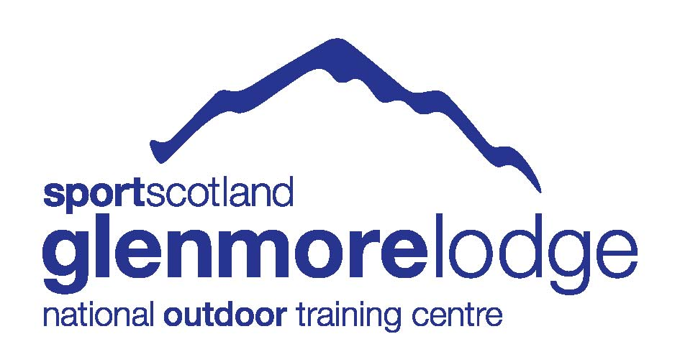

International Mountain Leader Summer Assessment
Home Preparation Paper 2023

Welcome to your IML Home Preparation Paper. This paper is designed to help you prepare for your assessment, requiring you to undertake further research to confirm areas of your knowledge. You should answer all questions clearly and concisely.
Many of these questions will be revisited during your assessment, when you should be prepared to explain, articulate and expand upon your written answers.
The results from this paper will be used in conjunction with the assessment course to give a holistic overview of your performance.

- Name three alpine plants which have medicinal properties and describe how might they be used to treat ailments (you should also be able to identify them on the hill).

- List a minimum of 6 ways you as a group leader would educate the group regarding ‘a minimum impact approach to trekking’.

- What do you understand by the term ‘eco tourism’

- How would you ensure that some of your groups money spent in country goes to the local economy?

- Educating the group about the local people and culture is a crucial part of the trek leader’s job. Give 5 examples of information that would be important for your group.

- Outline what you would include in a briefing for a group visiting a developing world country for the first time.

- What is the aim of the International porter protection group?

- When trekking with a group supported by porters and cook/cook boy etc. what responsibility do you have to them?

- What is an Epirb and how could it be of use to you as a leader, where could you buy one from, and what does in cost?

- On a very remote trek what form of communication could you, as the leader, carry to ensure contact in an emergency?

- What are prayer flags and why are they often seen high in the mountains?

- What are Stupa (Chorten in Tibetan) and where might you see them?

- Outline 5 possible hazards associated with fixed equipment found on European footpaths.

- What issues would you need to consider when advising your group on sanitary and human waste disposal and hygiene whilst trekking?

- Identify 4 High Alpine plants and explain how they have adapted to the harsh environment (you should also be able to identify them on the hill).

- Briefly describe how two different countries outside the UK legislate for the protection and conservation of mountainous terrain.

- What is the Via-Alpina and why was it developed?

- List the equipment you would carry when leading a group in rough and remote terrain in South America.

- What advice would you offer to your group before commencing a multi day trek at altitude, regarding health and altitude related issues?

- Where would you research for information regarding medical requirements when visiting a developing country and what information would you seek?

- You are leading a trek at 3500m when it is clear that one member is suffering with symptoms of AMS which they are trying to hide from you. They are two days and 700 metres from their life time’s ambition of the summit. They are suffering but keen to continue. Outline your actions.

- Passing by a village in India, the last village near the end of the trip, one of your clients is keen to give all their first aid kit and much of there clothing to the villages. What is your reaction?

- What is a ‘bisse’ and why could it be of interest to IML leaders?

- List 4 plants that offer something for your group to safely eat whilst trekking in the Alps (you should also be able to identify them on the hill).

- You are working for a respectable company with in-country guides who have been hired to cover the technical part of the trek. You are concerned that safety issues are not being addressed, and clients are in danger. What do you do?

- Is it important as members of a professional association we wear our badges when working, discuss?

- How does the footpath grading system work in Switzerland and how is this shown on Swiss maps?

- What emergency kit would you as the group leader carry when leading in the European Alps in the summer?

- Explain the following terms and what they mean
- Servitude de passage
- Betretungsrecht
- Fortgesetz
- Allemansratt.

- What information would a hut guardian require when receiving a booking?

- What methods are available for water purification, what are the pros and cons of each?

- What mammals would you commonly see whilst trekking in Europe? (you should also be able to identify them on the hill)

- When visiting a mountain hut in Europe with a group for their first overnight experience, what would you include in your briefing?

- When faced with an emergency whilst trekking with a group in Europe, how would you raise the alarm? What telephone numbers would be of use to you? If you could not obtain a phone signal what would you do?

- What 3 birds might you commonly see whilst trekking in the European Alps? (you should also be able to identify them on the hill)

- You are asked by a group to run a glacial walk on a popular glacier in France, what would your response be?

- Which countries are members of UIMLA?

- In which European Countries do you need an IML Award to operate legally?

- What in country administration is required to lead treks in Switzerland, Germany and Nepal?

- What do you take into consideration before deciding whether to use a rock spike as a direct or indirect anchor?

- What briefing would you give to a client who is descending a rock step whilst protected by a rope?

- Describe the following geographical features and how they are formed: anticline, sink hole, drumlin

- How are the following rock types formed and how would you identify them: granite, limestone, schist, obsidian?

- What coaching points or top tips would you give to a student to promote smooth and efficient movement over the following different types of terrain: loose scree, rocky steps, a steep open slope with close cropped vegetation, a boulder field?

- What are the symptoms of HAPE?

- What are the characteristics of the following weather features and how are they formed: Fohn wind, orographic lift and temperature inversion?

- What advice would you give to a client who is looking to improve their fitness prior to a three week high altitude trek in Nepal?

- What methods of physical assistance could you use to provide support for a client who is struggling to descend a steep loose path, excluding use of the rope?

- Translate the weather forecast below into English:

SITUATION GÉNÉRALE ET ÉVOLUTION
Crête anticyclonique 1025 hpa des Açores à la Suisse et entraînant une belle accalmie sur les Alpes jusqu'à vendredi avant une nouvelle série perturbée d'ouest de samedi à mercredi matin.
AUJOURD’HUI - JEUDI 31 OCTOBRE
Ensoleillé - froid le matin - doux l'après-midi
ÉTAT DU CIEL : clair ou peu nuageux - quelques passages de nuages élevés le matin. Ensoleillement proche de 95%.
PRÉCIPITATIONS : pas de précipitations.
VENT - fond de vallée : variable faible.
VENT - moyenne montagne : E faible à modéré -> S faible.
VENT - haute montagne : SW faible -> WSW faible à modéré.
TEMPÉRATURE : mini -1°C - maxi +15°C - inversion de température vers 1500 m au début de la matinée.
ISOTHERME 0°C : 2800 -> 3000 m.
ISOTHERME -10°C : 4600 -> 4700 m.

- You are trekking in the Spanish Pyrenees when one of your group slips and breaks their lower leg. The operator you get through to at the emergency services only speaks Spanish. Translate the information below so that you can ask for a helicopter rescue:

You are leading a group of six adults. One adult male has had an accident and suffered a broken lower right leg. You are requesting helicopter evacuation. Your location is at the col between Pic d’Mynedd and Mont LLagi at the head of the Ziettes Valley, grid reference SD 147239.The current weather is good visibility with a light northerly wind.

